Sequence Diagram of Library Management System (MVC Concept):

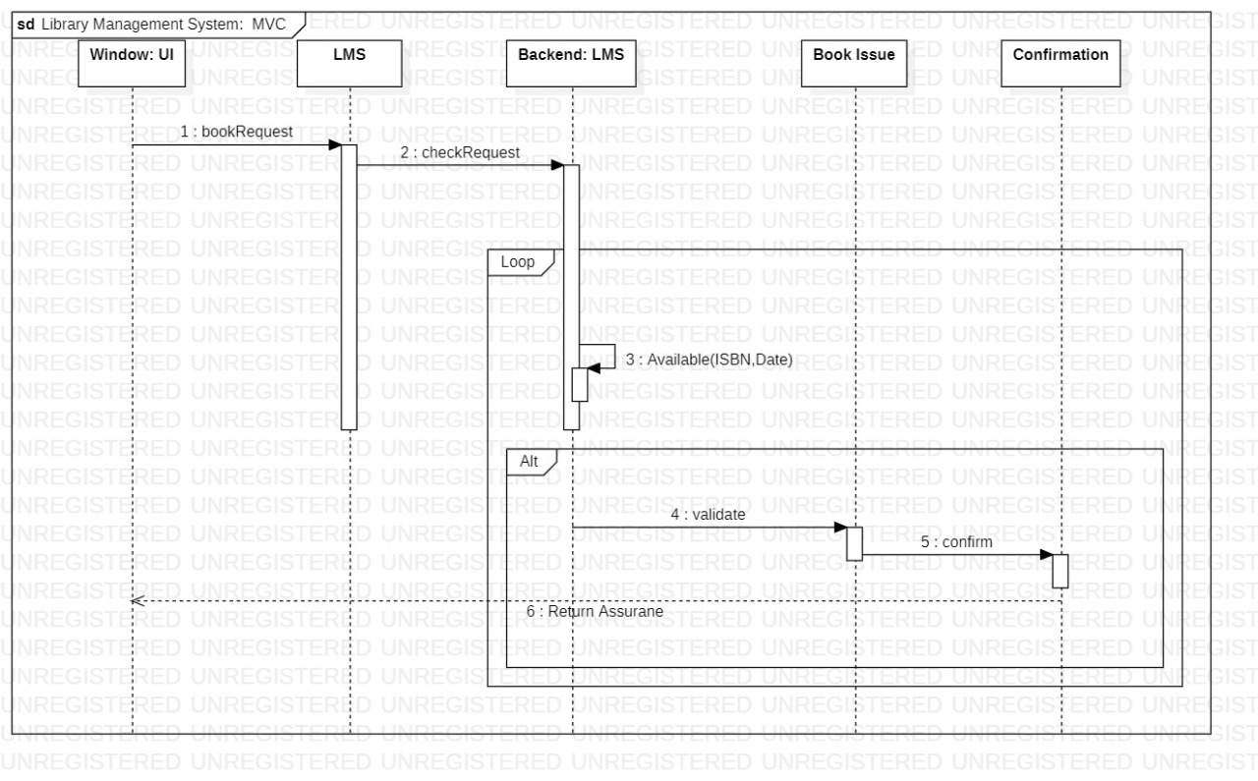

ClassDiagram of Library Management System (MVC Concept):

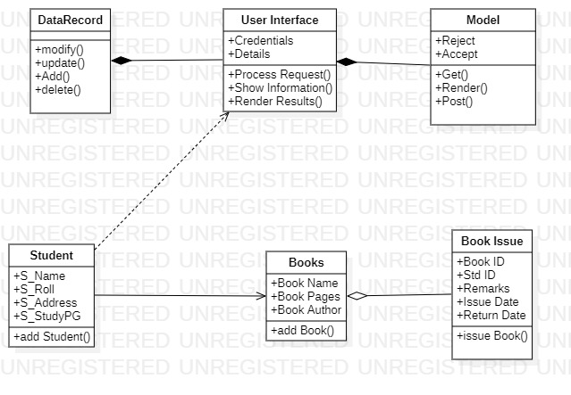

**Terminal:**







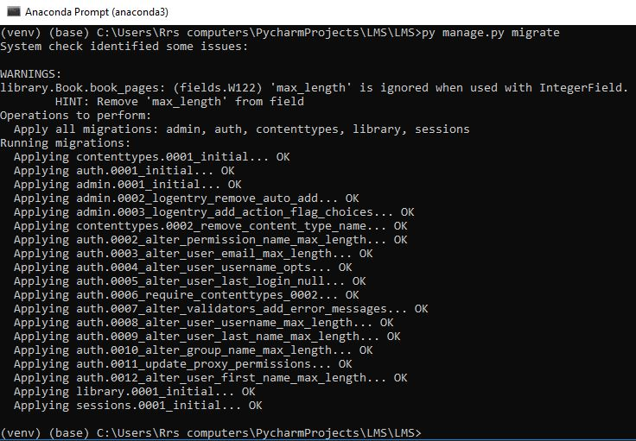



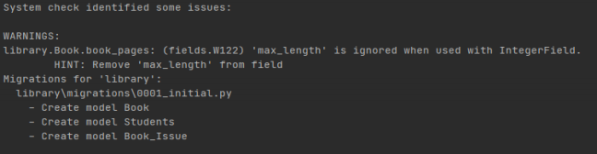

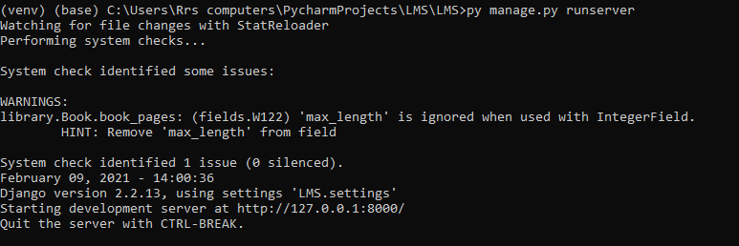

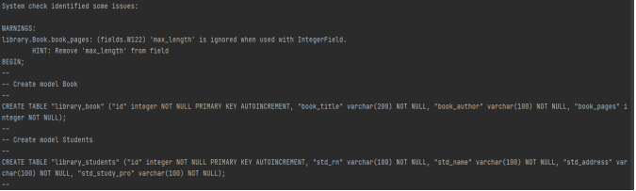

**Models.py**

**from django.db import models**

**from datetime import datetime,timedelta**

**class Students(models.Model):**

**std_rn = models.CharField(max_length=100)**

**std_name = models.CharField(max_length=100)**

**std_address = models.CharField(max_length=100)**

**std_study_pro = models.CharField(max_length=100)**

**def __str__(self):**

**return *self*.std_name**

**def __str__(self):**

**return str(*self*.std_rn)**

**class Book(models.Model):**

**book_title = models.CharField(max_length=200)**

**book_author = models.CharField(max_length=100)**

**book_pages = models.IntegerField(max_length=1000)**

**def __str__(self):**

**return *self*.book_title**

**def get_returndate():**

**return datetime.today() + timedelta(days=8)**

**class Book_Issue(models.Model):**

**student = models.ForeignKey('Students', on_delete=models.CASCADE)**

**book = models.ForeignKey('Book', on_delete=models.CASCADE)**

**issue_date = models.DateTimeField(auto_now=True)**

**return_date = models.DateTimeField(default=get_returndate())**

**remarks = models.CharField(max_length=100, default="Some Remarks")**

**def __str__(self):**

**return *self*.Students.std_name + " borrowed " + *self*.Book.book_title**

**Views.py**

**from django.shortcuts import render, redirect**

**from .forms import StudentsForm, BookForm, Book_IssueForm**

**from .models import Students, Book, Book_Issue**

**def index(request):**

**return(render(request, 'index.html'))**

**def new_form(request):**

**form = StudentsForm**

**return (render(request, 'new_form.html', {'form':form}))**

**def new2_form(request):**

**form = BookForm**

**return (render(request, 'new2_form.html', {'form':form}))**

**def new3_form(request):**

**form = Book_IssueForm**

**return (render(request, 'new3_form.html', {'form':form}))**

**def new_add(request):**

**form = StudentsForm(request.POST)**

**form.save()**

**return redirect('/show')**

**def new2_add(request):**

**form = BookForm(request.POST)**

**form.save()**

**return redirect('/show2')**

**def new3_add(request):**

**form = Book_IssueForm(request.POST)**

**form.save()**

**return redirect('/show3')**

**def view_st(request):**

**stud = Students.objects.order_by('-id')**

**return render(request,'view_st.html', {'stud': stud})**

**def view_b(request):**

**bk = Book.objects.order_by('-id')**

**return render(request,'view_b.html', {'bk': bk})**

**def view_bissue(request):**

**issue = Book_Issue.objects.order_by('-id')**

**return render(request,'view_bissue.html', {'issue': issue})**

**library/URLS.py**

**from django.urls import path**

**from . import views**

**urlpatterns = [**

**path('', views.index, name='index'),**

**path('new_form', views.new_form, name='new_form'),**

**path('new2_form', views.new2_form, name='new2_form'),**

**path('new3_form', views.new3_form, name='new3_form'),**

**path('add_new', views.new_add, name='NEW_ST_RECORD'),**

**path('add_new2', views.new2_add, name='NEW_B_RECORD'),**

**path('add_new3', views.new3_add, name='NEW_BI_RECORD'),**

**path('show', views.view_st, name='SHOW RECORD'),**

**path('show2', views.view_b, name='SHOW BOOK RECORD'),**

**path('show3', views.view_bissue, name='SHOW ISSUED RECORD'),**

**]**

**LMS/URLS.py**

**from django.urls import path, include**

**urlpatterns = [**

**path('', include('library.urls'))**

**]**

**Settings.py**

**# Application definition**

**INSTALLED_APPS = [**

**'django.contrib.admin',**

**'django.contrib.auth',**

**'django.contrib.contenttypes',**

**'django.contrib.sessions',**

**'django.contrib.messages',**

**'django.contrib.staticfiles',**

**'library',**

**]**

**Forms.py**

**from django import forms**

**from .models import Students, Book, Book_Issue**

**class StudentsForm(forms.ModelForm):**

**class Meta:**

**model = Students**

**fields = '__all__'**

**class BookForm(forms.ModelForm):**

**class Meta:**

**model = Book**

**fields = '__all__'**

**class Book_IssueForm(forms.ModelForm):**

**class Meta:**

**model=Book_Issue**

**exclude = ['issue_date', 'return_date']**

**Index.html**

**{% extends 'base.html' %}**

**<html lang="en">**

**<head>**

**<meta charset="UTF-8">**

**<title>HOME PAGE</title>**

**<link href="https://cdn.jsdelivr.net/npm/bootstrap@5.0.0-beta1/dist/css/bootstrap.min.css" rel="stylesheet"**

**integrity="sha384-giJF6kkoqNQ00vy+HMDP7azOuL0xtbfIcaT9wjKHr8RbDVddVHyTfAAsrekwKmP1" crossorigin="anonymous">**

**</head>**

**<body>**

**{% block content %}**

**<h1 style="font-family:monospace; font-size:70px; background-color: white;">Library Management System</h1>**

**<hr>**

**<img src="https://st2.depositphotos.com/2404187/7392/v/380/depositphotos_73929527-stock-illustration-online-library-education-concept-flat.jpg">**

**<style>**

**img{**

**border-radius:3em;**

**}**

**</style>**

**{% endblock %}**

**</body>**

**</html>**

**Base.html**

**<html lang="en">**

**<head>**

**<meta charset="utf-8">**

**<meta name="viewport" content="width=device-width, initial-scale=1">**

**<link rel="stylesheet" href="https://maxcdn.bootstrapcdn.com/bootstrap/3.4.1/css/bootstrap.min.css">**

**<script src="https://ajax.googleapis.com/ajax/libs/jquery/3.5.1/jquery.min.js"></script>**

**<script src="https://maxcdn.bootstrapcdn.com/bootstrap/3.4.1/js/bootstrap.min.js"></script>**

**</head>**

**<body>**

**<nav class="navbar navbar-inverse">**

**<div class="container-fluid">**

**<div class="navbar-header">**

**<a class="navbar-brand" href="#">LIBRARY MANAGEMENT SYSTEM</a>**

**</div>**

**<ul class="nav navbar-nav">**

**<li class="active"><a href="/">Home</a></li>**

**<li><a href="new_form">Add Student</a></li>**

**<li><a href="new2_form">Add Book</a></li>**

**<li><a href="new3_form">Add Issue Book</a></li>**

**<li><a href="show">Students</a></li>**

**<li><a href="show2">Books</a></li>**

**<li><a href="show3">Books Issued</a></li>**

**</ul>**

**<form class="navbar-form navbar-left" action="/search" method="post"> {%csrf_token%}**

**<div class="form-group">**

**<input type="text" class="form-control" name="sname" placeholder="Search">**

**</div> <button type="submit" class="btn btn-primary">Submit</button>**

**</form>**

**</div>**

**</nav>**

**{% block content %}**

**{% endblock %}**

**<style>**

**body{**

**background-image: url('https://st2.depositphotos.com/4504991/8518/v/950/depositphotos_85189492-stock-illustration-seamless-background-with-books.jpg');**

**text-align:center;**

**}**

**form{**

**margin-top:13em;**

**}**

**</style>**

**</body>**

**</html>**

**New_form1:**

**{% extends 'base.html' %}**

**<html lang="en">**

**<head>**

**<meta charset="UTF-8">**

**<title>Add New Student</title>**

**</head>**

**<body>**

**{% block content %}**

**<div class="form" style="background-color: white; display: inline-block; padding: 50px; padding-bottom: 50px; border-radius: 15px;">**

**<form method="POST" action="add_new" class="form-inline">**

**{% csrf_token %}**

**<label>Roll Number:</label><br><div>{{form.std_rn}}</div>**

**<label>Student Name:</label><br> <div> {{form.std_name}}</div>**

**<label>Student Address:</label><br> <div> {{form.std_address}}</div>**

**<label>Student Study Program:</label><br> <div>{{form.std_study_pro}}</div>**

**<br> <button type="submit" class="btn btn-primary">Add Student</button>**

**</form>**

**</div>**

**{% endblock %}**

**<style>**

**.form{**

**margin-left:50em;**

**border: black solid 2px;**

**}**

**</style>**

**</body>**

**</html>**

**New_form2:**

**{% extends 'base.html' %}**

**<html lang="en">**

**<head>**

**<meta charset="UTF-8">**

**<title>Add New Book</title>**

**</head>**

**<body>**

**{% block content %}**

**<div style="background-color: white; display: inline-block; padding: 50px; padding-bottom: 50px; border-radius: 15px;">**

**<form method="POST" action="add_new2" class="form-inline">**

**{% csrf_token %}**

**<label>Book Title.</label><br><div>{{form.book_title}}</div>**

**<label>Book Author.</label><br> <div> {{form.book_author}}</div>**

**<label>Book Pages.</label><br> <div> {{form.book_pages}}</div>**

**<br> <button type="submit" class="btn btn-primary>Add Book</button> </form>**

**</div>**

**{% endblock %}**

**</body>**

**</html>**

**NewForm3:**

**{% extends 'base.html' %}**

**<html lang="en">**

**<head>**

**<meta charset="UTF-8">**

**<title>Add Book Issue</title>**

**</head>**

**<body>**

**{% block content %}**

**<div style="background-color: white; display: inline-block; padding: 50px; padding-bottom: 50px; border-radius: 15px;">**

**<form method="POST" action="add_new3" class="form-inline">**

**{% csrf_token %}**

**<label>Student ID</label><br><div>{{form.student}}</div>**

**<label>Book ID</label><br> <div> {{form.book}}</div>**

**<label>Issue Date</label><br> <div> {{form.issue_date}}</div>**

**<label>Return Date</label><br> <div>{{form.return_date}}</div>**

**<label>Remarks</label><br> <div> {{form.remarks}}</div>**

**<br> <button type="submit" class="btn btn-primary">Issue Book</button> </form>**

**</div>**

**{% endblock %}**

**</body>**

**</html>**

**View_1.html:**

**{% extends 'base.html' %}**

**<html lang="en">**

**<head>**

**<meta charset="UTF-8">**

**<title>HOME PAGE</title>**

**</head>**

**<body>**

**{% block content %}**

**<table class="table table-striped">**

**<tr>**

**<th>Book title </th>**

**<th>Book author </th>**

**<th>Book pages </th>**

**<th>Actions</th>**

**</tr>**

**{%for b in bk%}**

**<tr>**

**<td>{{b.book_title}}</td>**

**<td>{{b.book_author}}</td>**

**<td>{{b.book_pages}}</td>**

**<td><a href="edit/{{b.id}}">Edit </a> | <a**

**href="delete/{{b.id}}">Delete</a></td>**

**</tr> {% endfor %}**

**</table>**

**{% endblock %}**

**</body>**

**</html>**

**View_bissue:**

**{% extends 'base.html' %}**

**<html lang="en">**

**<head>**

**<meta charset="UTF-8">**

**<title> Issue Records </title>**

**</head>**

**<body>**

**{% block content %}**

**<table class="table table-striped">**

**<tr>**

**<th>Student ID </th>**

**<th>Book ID </th>**

**<th>Issue Date </th>**

**<th>Return Date</th>**

**<th>Remarks</th>**

**</tr>**

**{%for i in issue%}**

**<tr>**

**<td>{{i.student}}</td>**

**<td>{{i.book}}</td>**

**<td>{{i.issue_date}}</td>**

**<td>{{i.return_date}}</td>**

**<td>{{i.remarks}}</td>**

**<td><a href="edit/{{i.id}}">Edit </a> | <a**

**href="delete/{{i.id}}">Delete</a></td>**

**</tr> {% endfor %}**

**</table>**

**{% endblock %}**

**</body>**

**</html>**

**View.ST:**

**{% extends 'base.html' %}**

**<html lang="en">**

**<head>**

**<meta charset="UTF-8">**

**<title>HOME PAGE</title>**

**</head>**

**<body>**

**{% block content %}**

**<table class="table table-striped">**

**<tr>**

**<th>Student Roll no </th>**

**<th>Student Name </th>**

**<th>Student Address </th>**

**<th>Student Study Program </th>**

**<th>Actions</th>**

**</tr>**

**{%for s in stud%}**

**<tr>**

**<td>{{s.std_rn}}</td>**

**<td>{{s.std_name}}</td>**

**<td>{{s.std_address}}</td>**

**<td>{{s.std_study_pro}}</td>**

**<td><a href="edit/{{s.id}}">Edit </a> | <a**

**href="delete/{{s.id}}">Delete</a></td>**

**</tr> {% endfor %}**

**</table>**

**{% endblock %}**

**</body>**

**</html>**

**LMS Site:**

